CRCC Churchwide Survey August 2020

Respondents
- 122 adults
  - including 24 seniors
- 4 MS/HS youth
- 9 children

Adults and Seniors

Sunday service
- 81 respondents (66%) watch most weeks
  - 47 (39% of respondents) watch on Sunday morning
  - 27 (22% of respondents) watch later on Sundays
  - 7 (6% of respondents) watch later in the week
- 97 respondents (80%) watch on Sundays most weeks or sometimes
- 60 respondents (49%) watch on Sunday morning most weeks or sometimes
- Only 2 respondents never watch the service

Main reasons to watch on Sunday morning
- Community/connection
- Spiritual input
- Commitment/routine
- Sense of normalcy

Main reasons not to watch on Sunday morning
- Not as engaging online
- Scheduling conflicts/too busy/kids need attention
- Too much time online
- Forget/wake up late
- Watch another church service

Other determining factors
- Topic/speaker
- Weather
- Mood

Comfort with meeting in person
- 34% of respondents scored 8-10 (comfortable)
  - 34% of non-senior adults scored 8-10
  - 33% of seniors scored 8-10
- 29% of respondents scored 1-3 (uncomfortable)
  - 21% of non-senior adults scored 1-3
  - 54% of seniors scored 1-3
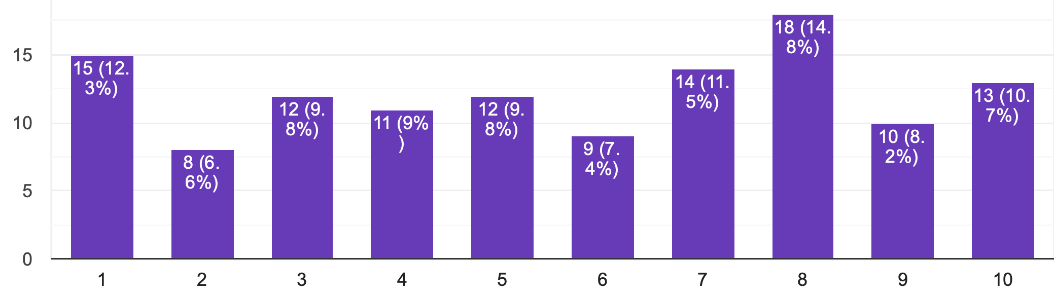
Very uncomfortable Very comfortable

Factors influencing comfort with meeting in person
- 70% of respondents did not want to put others at risk
- 61% questioned our community’s ability to comply with the guidelines
- 60% were concerned about their own risk
- 48% felt a need for community
- 21% felt a need for normalcy

Racial justice encounter group attendance
- 49 respondents (40%) have attended a group
- 73 respondents (60%) have not attended a group

Content attenders are interested in
- 65% want opportunities to take action
- 63% want to attend groups for learning and action planning
- 59% want opportunities to learn with others (e.g., book clubs, documentary screenings)
- 24% are members of other racial justice groups
- One respondent specified an interest in racial equity in education

Content non-attenders are interested in
- 41% want opportunities to take action
- 37% want opportunities to learn with others (e.g., book clubs, documentary screenings)
- 33% are members of other racial justice groups
- 25% want to attend groups for learning and action planning
- 5 respondents are not interested in racial justice
- 2 respondents appreciate the integration of racial justice into the Sunday services; one did not
- One respondent wanted a “more Christ-centered,” less secular and political approach
Respondents who are caregivers to children and youth
- 56 respondents (46%) are caregivers

Parents reporting children watching Sunday services
- Of the 14 preschool children
  - 1 (7%) watches the children’s lesson most weeks
  - 3 (21%) sometimes watch the children’s lesson
  - 5 (36%) rarely watch the children’s lesson
  - 5 (36%) never watch the children’s lesson
  - 5 (36%) watch the adult service most weeks
  - 1 (7%) sometimes watch the adult service
  - 5 (36%) rarely watch the adult service
- Of the 23 elementary children
  - 5 (22%) watch the children’s lesson most weeks
  - 3 (13%) sometimes watch the children’s lesson
  - 7 (30%) rarely watch the children’s lesson
  - 6 (26%) never watch the children’s lesson
  - 5 (22%) rarely watch the adult service
  - 2 (9%) sometimes watch the adult service
- Of the 8 MS children
  - 2 (25%) sometimes watch the service
  - 3 (38%) rarely watch the service
  - 3 (38%) never watch the service
- Of the 23 HS children
  - 1 (4%) watches the service most weeks
  - 6 (26%) sometimes watch the service
  - 7 (30%) rarely watch the service
  - 9 (39%) never watch the service
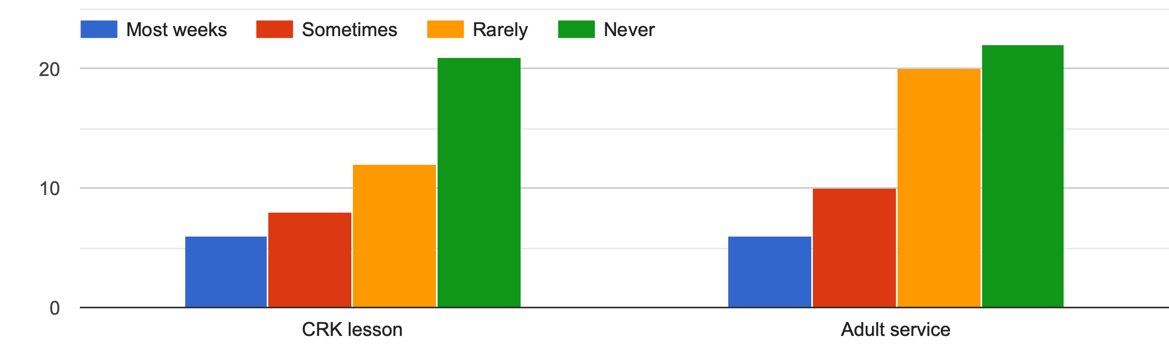

Things they like about the children’s lessons
- Bryan’s stories
- Videos
- Songs
- Seeing Cedar Ridge
- Sense of normalcy

Things they don’t like about the children’s lessons
- Songs
- Activities (hit and miss)
- Discussion questions

How can Cedar Ridge support families
Of the 50 people who responded:
- 27 (54%) would like socially distanced kids/youth gatherings
  - 4 respondents were parents to preschoolers
  - 8 respondents were parents to elementary children only
  - 5 respondents were parents to MS youth
  - 14 respondents were parents to HS youth
- 21 (42%) would like interactive zoom gatherings for kids/youth
  - 2 respondents were parents to preschoolers
  - 8 respondents were parents to elementary children
  - 2 respondents were parents to MS youth
  - 9 respondents were parents to HS youth
- 20 (40%) would like lessons requiring minimal parental involvement
  - 6 respondents were parents to preschoolers
  - 13 respondents were parents to elementary children
  - 3 respondents were parents to MS/HS youth
- 11 (22%) would like interactive zoom gatherings for parents
  - 4 respondents were parents to preschoolers
  - 5 respondents were parents to elementary children
  - 1 respondent was a parent to MS youth
  - 1 respondent was a parent to HS youth
- 10 (20%) would like interactive lessons with parental involvement required
  - 2 respondents were parents to preschoolers
  - 6 respondents were parents to elementary children
  - 1 respondent was a parent to MS youth
  - 1 respondent was a parent to HS youth

Other comments
Common themes:
- Gratitude for online services
- Appreciation for property
- Desire to get together in person outdoors
- Desire for more ways to interact during the service
- Desire for more opportunities to serve

MS and HS Youth

Sunday service
- 2 watch most weeks
- 1 watches sometimes
- 1 never watches

Reasons to watch
- I go to church for community not religion
- Contact to the outside world
- If I'm really tired, I might decide to watch it latter and then forget to watch
- Keeping in touch with God and watching the services with my mom

Comfort with meeting in person
- 1 scored 7
- 2 scored 8
- 1 scored 9

Factors influencing comfort with meeting in person
- 3 want to get together with other youth
- 3 want a sense of normalcy
- 1 wants to feel safe
- 1 doesn’t want to risk others’ safety

Convenient times to meet on the property
- Weekends mostly
- Weekend evenings
- Sometime on the weekend, probably
- Sundays

Racial justice encounter group attendance
- 1 attended a group

Content of interest
- 2 want opportunities to take action
- 2 are interested in groups to learn and plan action
- 1 is not interested in racial justice

Other comments
- I miss you guys
- We could do a church wide game night on Zoom

Children

Age of respondents
- 9 children responded
- Ages varied between 4 and 10
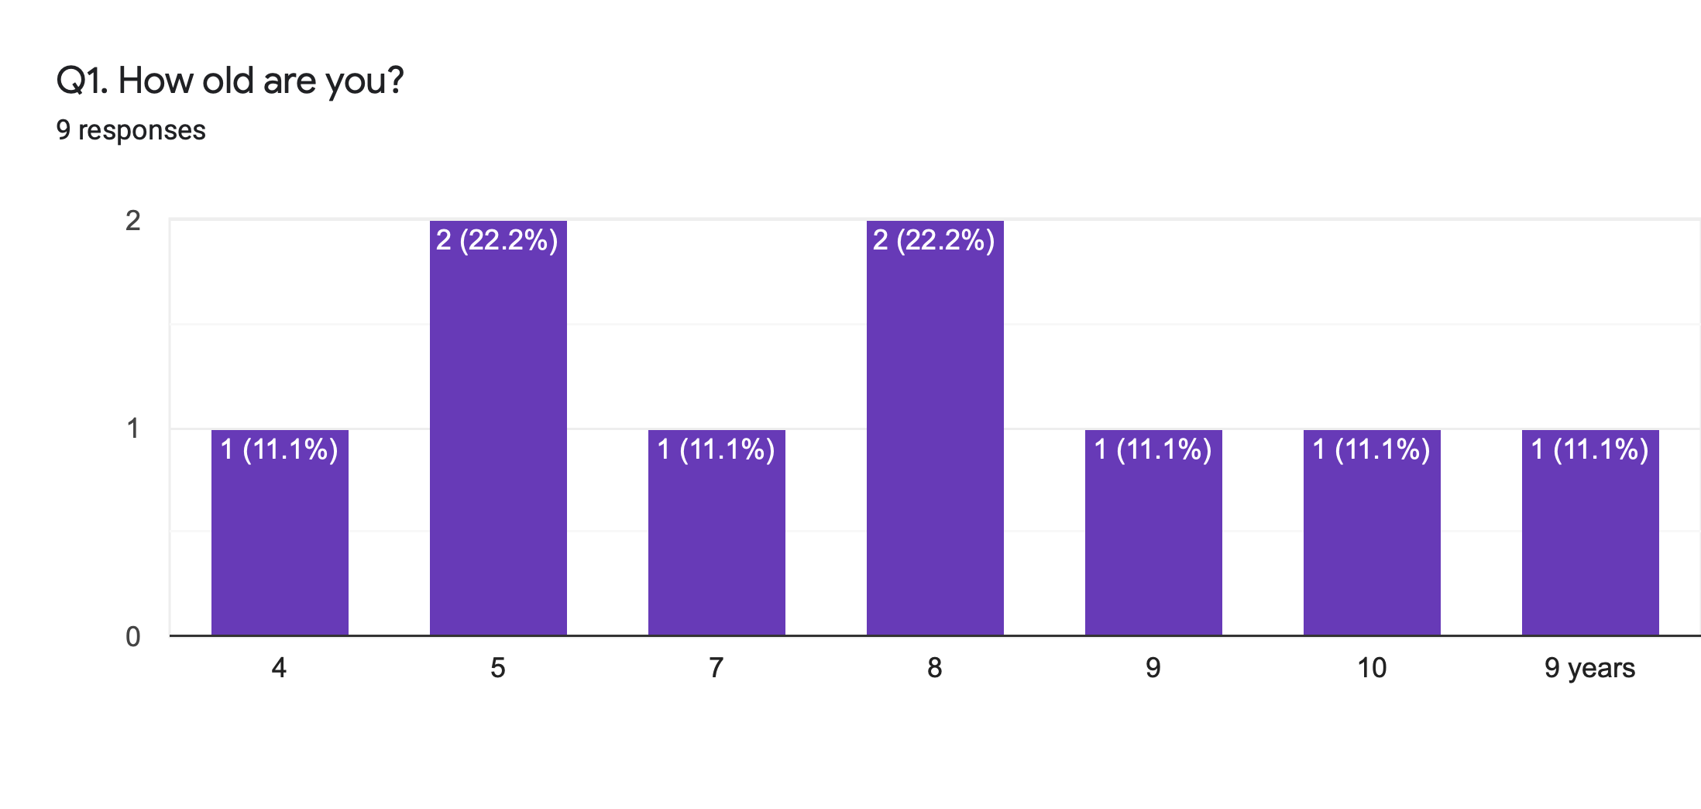
Sunday service
- 2 respondents watch the pre-k lesson sometimes or most weeks—and the adult service most weeks
- 5 watch the CRK lesson most weeks—3 of whom also watch the adult service sometimes
- 1 watches the CRK lesson rarely
- 1 watches the CRK lesson sometimes

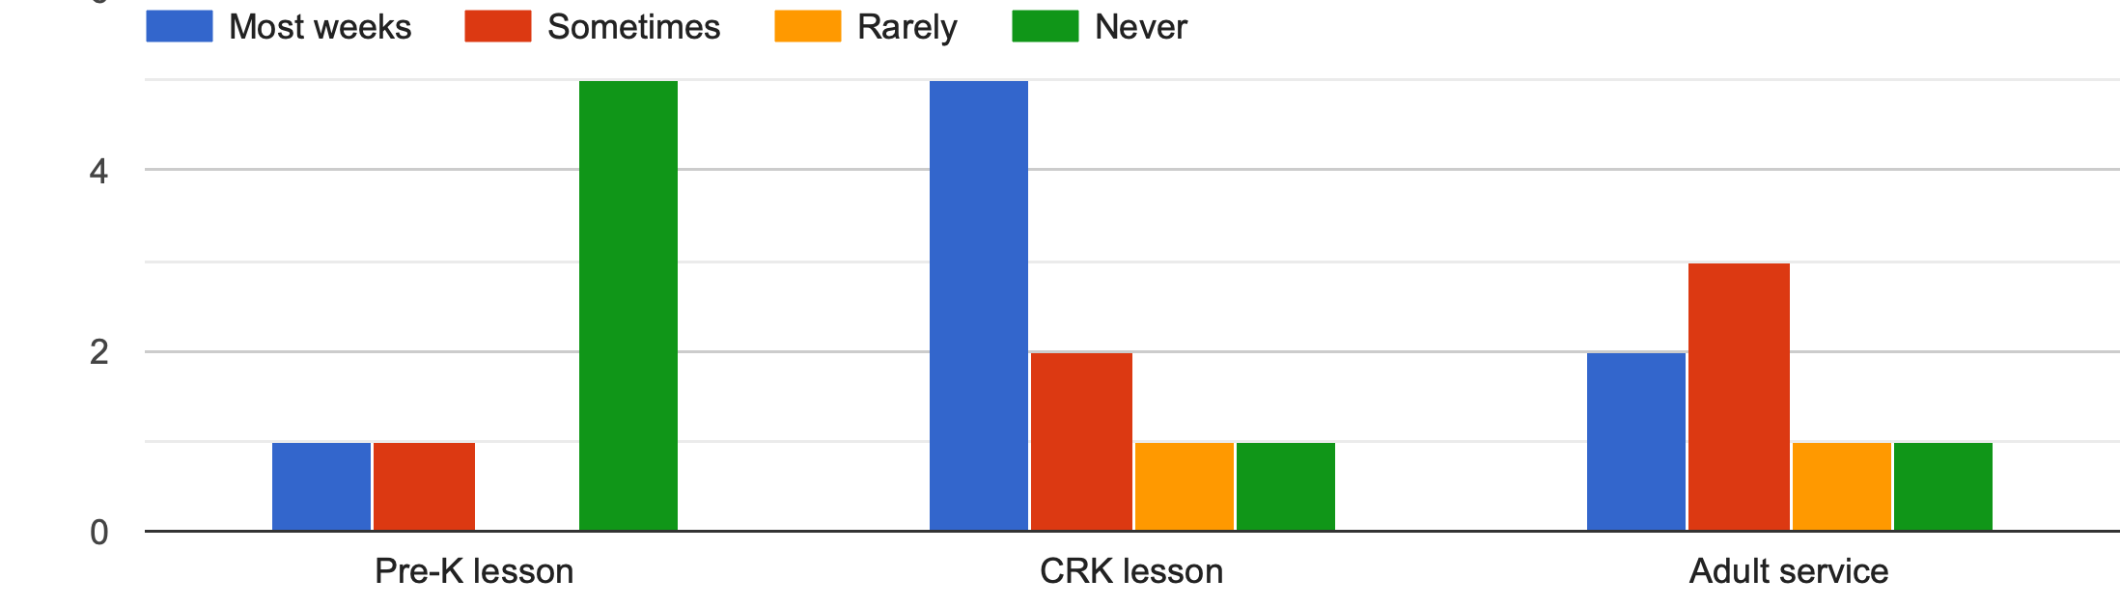

Reasons for watching
- My parents want me to/make me (x2)
- May parents watch it with me (x2)
- Because I love it/it’s fun (x2)
- To learn about God
- I just watch it
- I don't watch the adult one because it's a little boring for me.

Favorite part
- Videos (x4)
- Stories/Bryan (x4)
- Music
- I like doing it with my family

Feelings about going back to school virtually

Ways CRCC can help
- Donuts and bagels
- Help us learn about God
- Celebrate my birthday
- To give my family some church zoom call for the kids and parents. Also later when it is a safer time we might be able to go back (with masks) and have a good time. Also I am happy that Cedar Ridge is making some outdoors activities for the fall.

